Johnny Li

EEL3111C

Tuesday P.10-11

Lab 4-Write Up

Introduction

The goal of this lab is to analysis the effects of input resistance and output resistance on a controlled voltage sources, while also introducing the concept of an operational amplifier and feedback. To explore the effects of resistance on a controlled voltage source several circuit designs, including the ideal, with resistance, and with a load resistance, will undergo Monte Carlo simulations and be analyze. The properties of an operational amplifier are discovered through designing one with feedback and applying worst case analysis to acquire its limitation and cost.

Discussion

4.5.1 Worst Case Analysis

Figure 1: Output voltage plot for a 5% tolerance and the highest and lowest output voltage cases. Design is based on Figure 4.6 (a) in the lab manual.

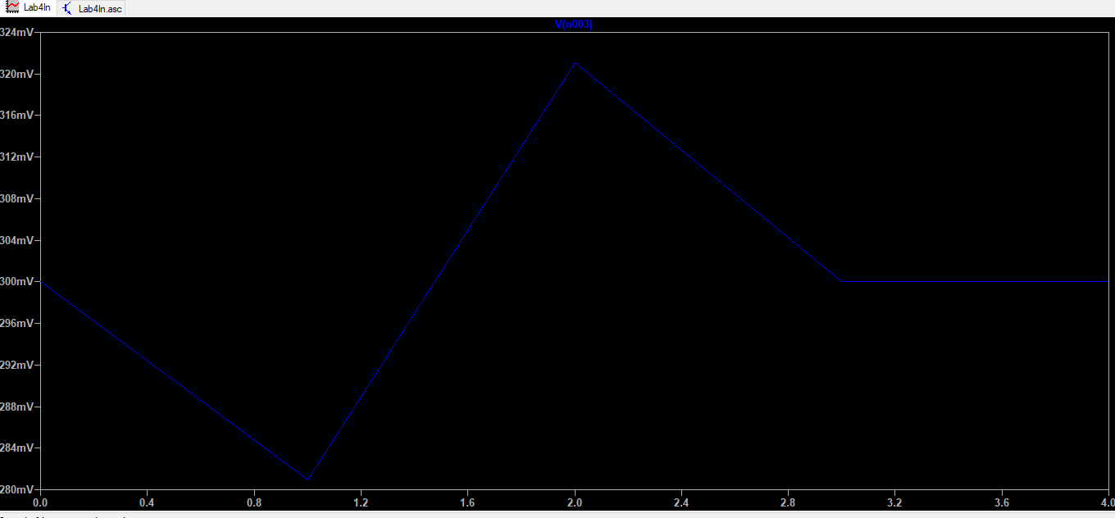

|  |  |  |  |
| --- | --- | --- | --- |
| Table 1: Non-inverting configuration- Worst Case Voltage and Pricing for the Tolerances | | | |
| Tolerances | High Voltage (mV) | Low Voltage (mV) | Minimum Cost ($) |
| 0.05 | 324 mV | 280 mV | $0.10 |
| 0.01 | 304 mV | 296 mV | $0.10 |
| 0.005 | 302.4 mV | 298 mV | $0.12 |
| 0.001 | 300.32 mV | 299.52 mV | $0.33 |
| 0.0005 | 300.2 mV | 299.76 mV | $0.77 |
| 0.0001 | 300.04 mV | 299.95 mV | $2.15 |

Table 1: Tabled output voltage range and pricing for different resistor tolerances. Design is based on Figure 4.6 (a) in the lab manual. The minimum cost of the resistors was chosen to mitigate the expense of the design.

Figure 2: Output voltage plot for a 5% tolerance and the highest and lowest output voltage cases.

Design is based on Figure 4.6 (b) in the lab manual.

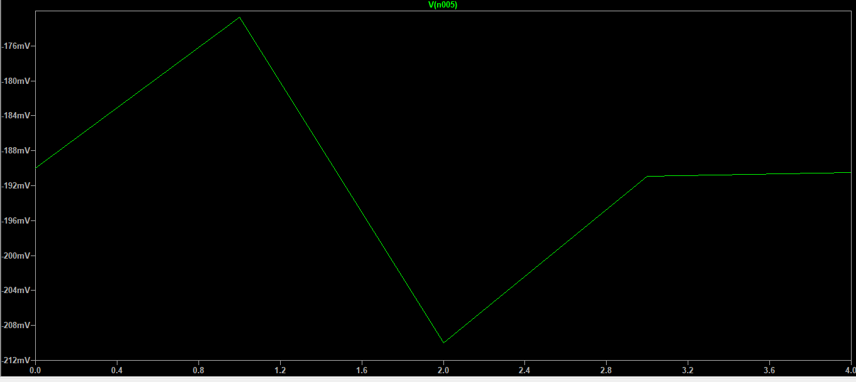

|  |  |  |  |
| --- | --- | --- | --- |
| Table 2: Inverting configuration- Worst Case Voltage and Pricing for the Tolerances | | | |
| Tolerances | High Voltage (mV) | Low Voltage (mV) | Minimum Cost ($) |
| 0.05 | -176 mV | -212 mV | $0.10 |
| 0.01 | -186.9 mV | -194.6 mV | $0.10 |
| 0.005 | -188.8 mV | -192.4 mV | $0.11 |
| 0.001 | -190.05 mV | -190.89 mV | $0.36 |
| 0.0005 | -190.32 mV | -190.68 mV | $0.77 |
| 0.0001 | -190.44 mV | -190.52 mV | $2.15 |

Table 2: Tabled output voltage range and pricing for different resistor tolerances. Design is based on Figure 4.6 (b) in the lab manual. The minimum cost of the resistors was chosen to mitigate the expense of the design.

Both circuit models, non-inverting (a) and inverting (b) configurations, incorporated negative feedback into their circuit design. The benefits of negative feedback are that it subtracts from the input signals thus, if the systems output changes, the negative feedback would counteract the change. The feedback systems form a loop meaning that the signal flow only from the output to the input of the system, making the gain of the system independent of the load and source. The benefits from feedback allows for a more isolated system which leads to greater control on the constant values of the system.

The results from the tables demonstrate that as the resistor tolerance decreases then the voltage range becomes more accurate to a single value. Base on the tables, the voltage values decreases and obtains more decimals values as the resistor tolerance decreases thus becoming a more defined lower value. This means that the initial voltage range from the 5% tolerance resistor is too broad and that the actual voltage range is originally at a lower range. It can also be seen that the voltage range different also reduces as in table 1 with the tolerance being at 5% there was a voltage different of 44 mV at the voltage output while the resistor with a 1% resistance tolerance had a voltage different of 8 mV at the voltage output, thus the results are becoming more exact. A similar circumstance is seen in table 2 as with the tolerance being at 5% there was a voltage different of -36 mV at the voltage output while the resistor with a 1% resistance tolerance had a voltage different of -7.7 mV at the voltage output, thus the results are also becoming more exact. However, the voltage source of the inverting configuration (b) are negative while the non-inverting (a) configuration is positive. This is because the input voltage is going into the positive terminal in the non-inverting (a) configuration thus making it positive while the input voltage is going into the negative terminal in the inverting (b) configuration thus making it negative.

The minimum cost of the resistors was chosen to mitigate the expense of the design. As seen in both tables, the cost of resistors with a tighter tolerance tend to have a higher minimum price. The minimum price of a resistor with 5% tolerance is approximately $0.10 whereas the resistor with a 0.01% tolerance has a minimum price of $2.12.

Conclusion

In conclusion, feedback allows greater control on the constant values of the system. Also, the worst-case analysis for different resistor tolerances is that as the resistor tolerance decreases then the voltage range becomes more accurate to a single value. By choosing the minimum price of the resistors it would mitigate the expense of the circuit design, thus saving money.